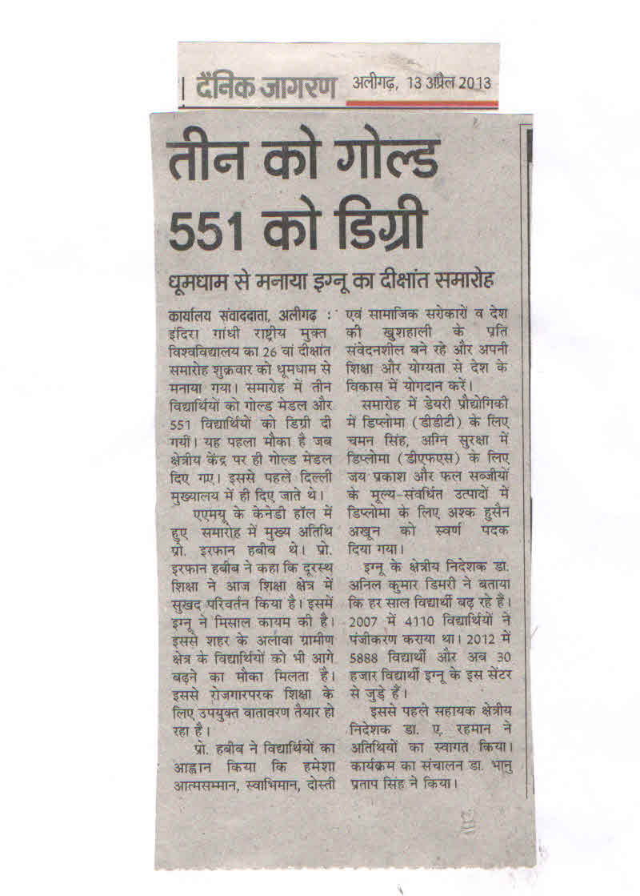
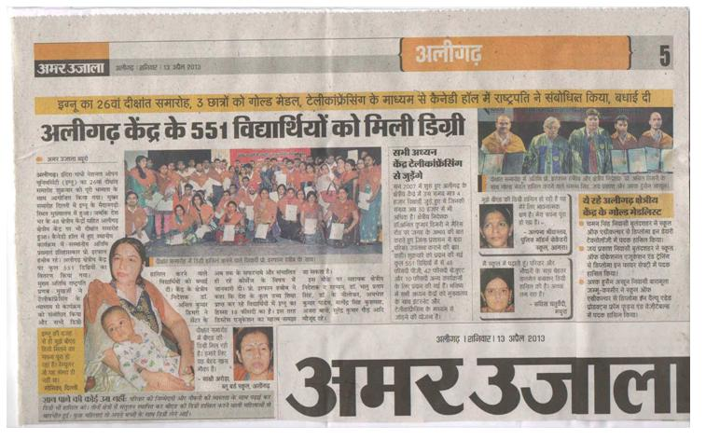
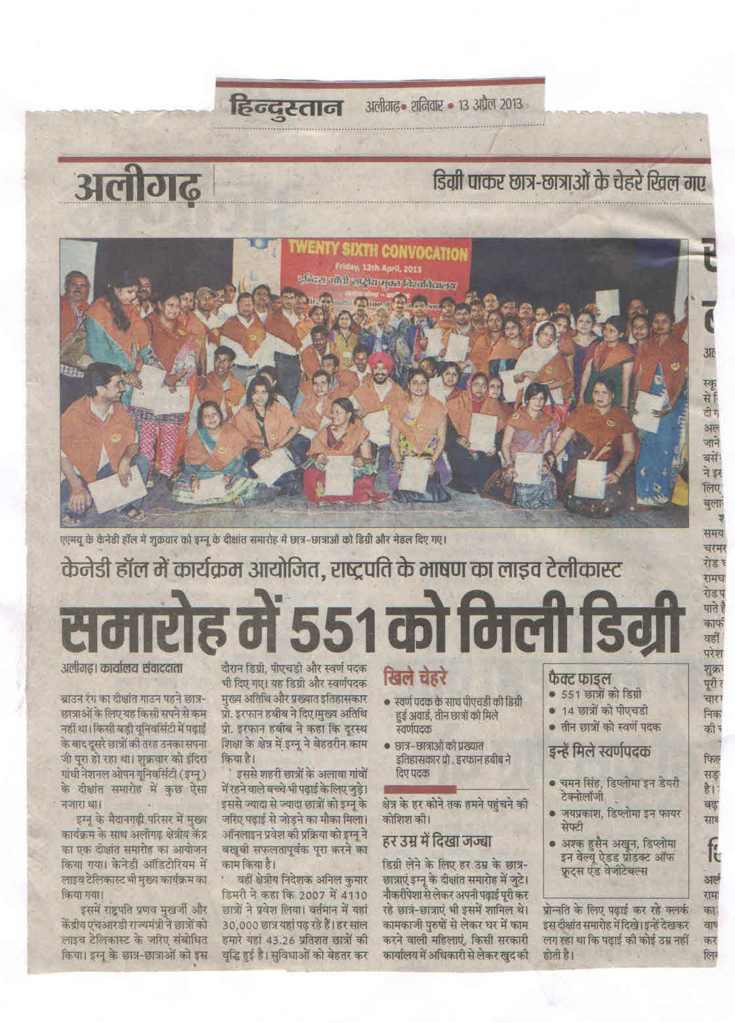

.

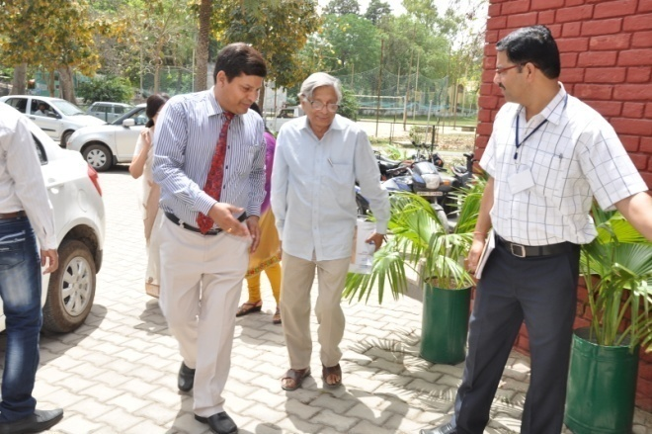Dr. A.K. Dimri, Regional Director & Mr. A. K. Pandey, Asstt. Registrar receiving
the Guest of Honour
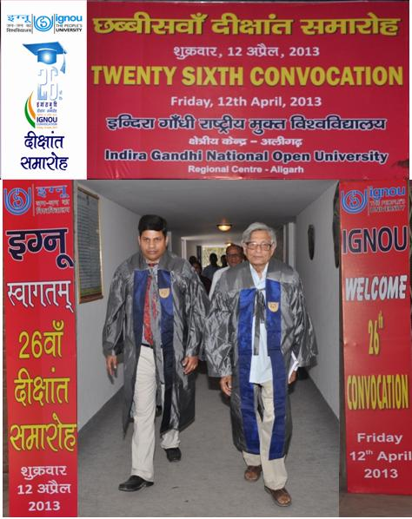
Academic Procession Enters the Convocation Hall
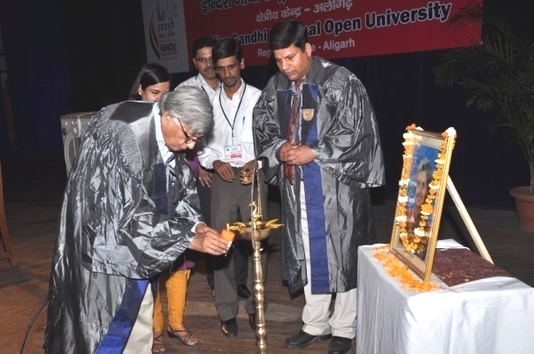
LIGHING of LAMP by ‘GUEST OF HONOUR’
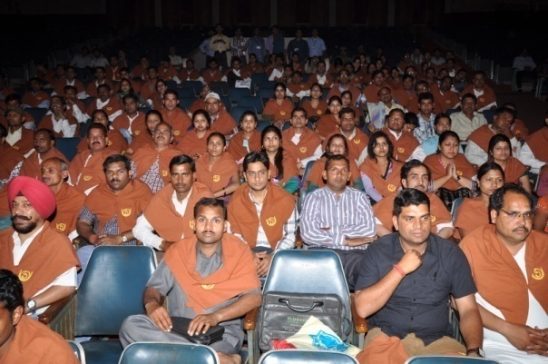
Students Participating 26th Convocation
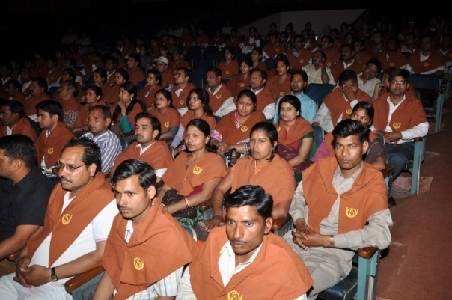
Awardees Participating in the
26th Convocation
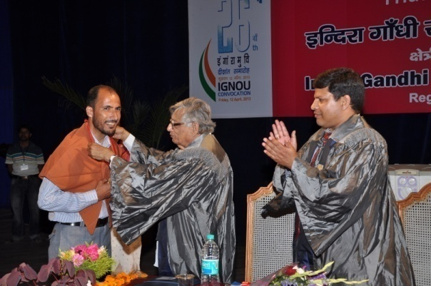
Gold Medal being awarded to Mr. Ashq Husain Aqoon (DVAPFV) by
Guest of Honour
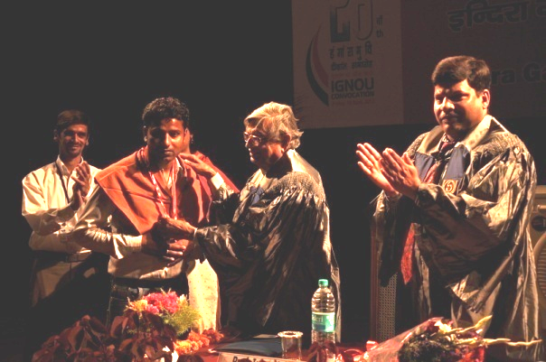
Gold Medal being awarded to
Mr. Chaman Singh (DDT)
by Guest of Honour
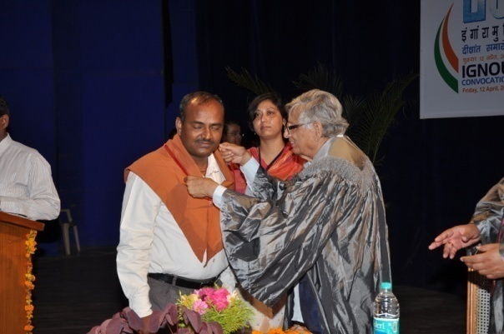
Gold Medal being awarded to Mr. Jai Prakash (DFS) by Guest of Honour
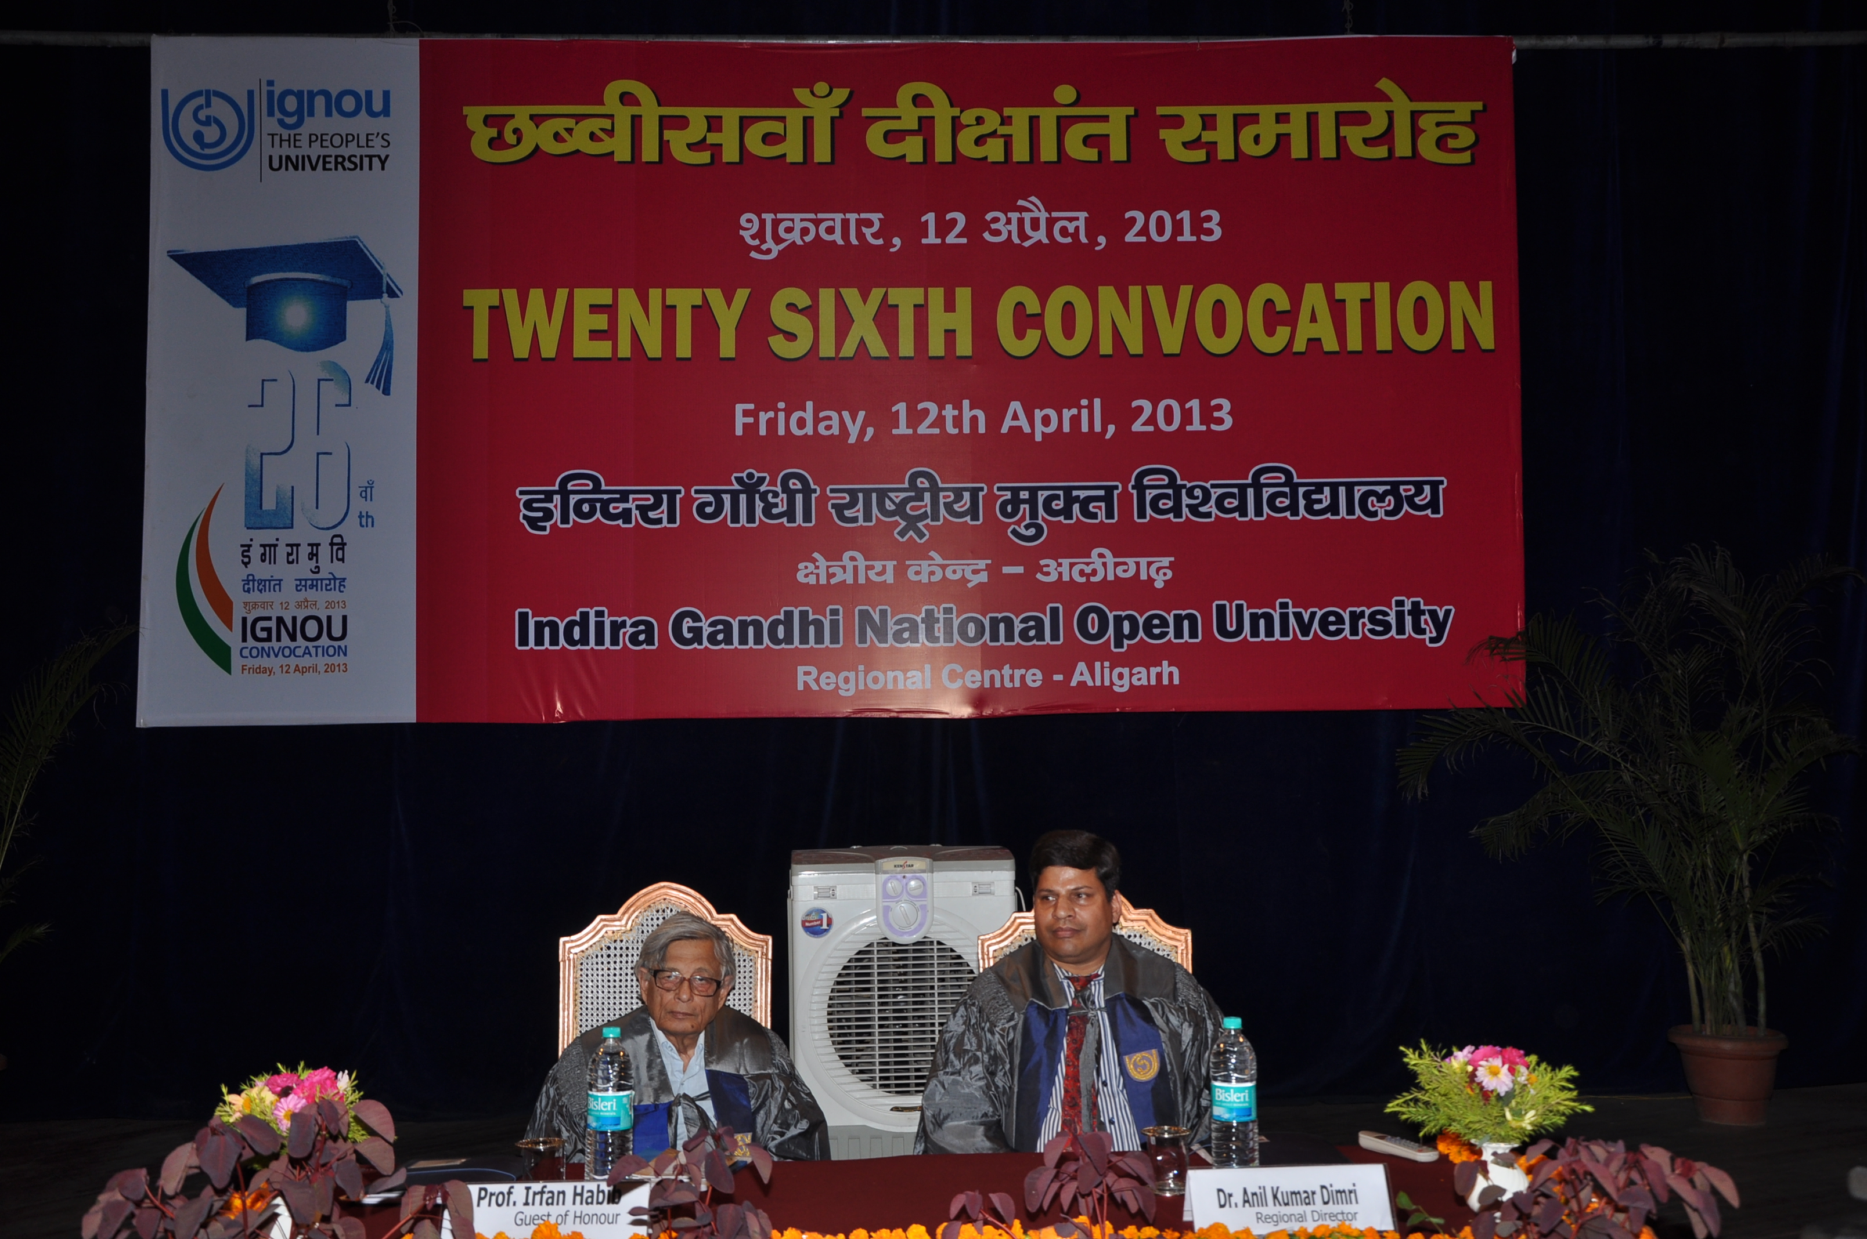
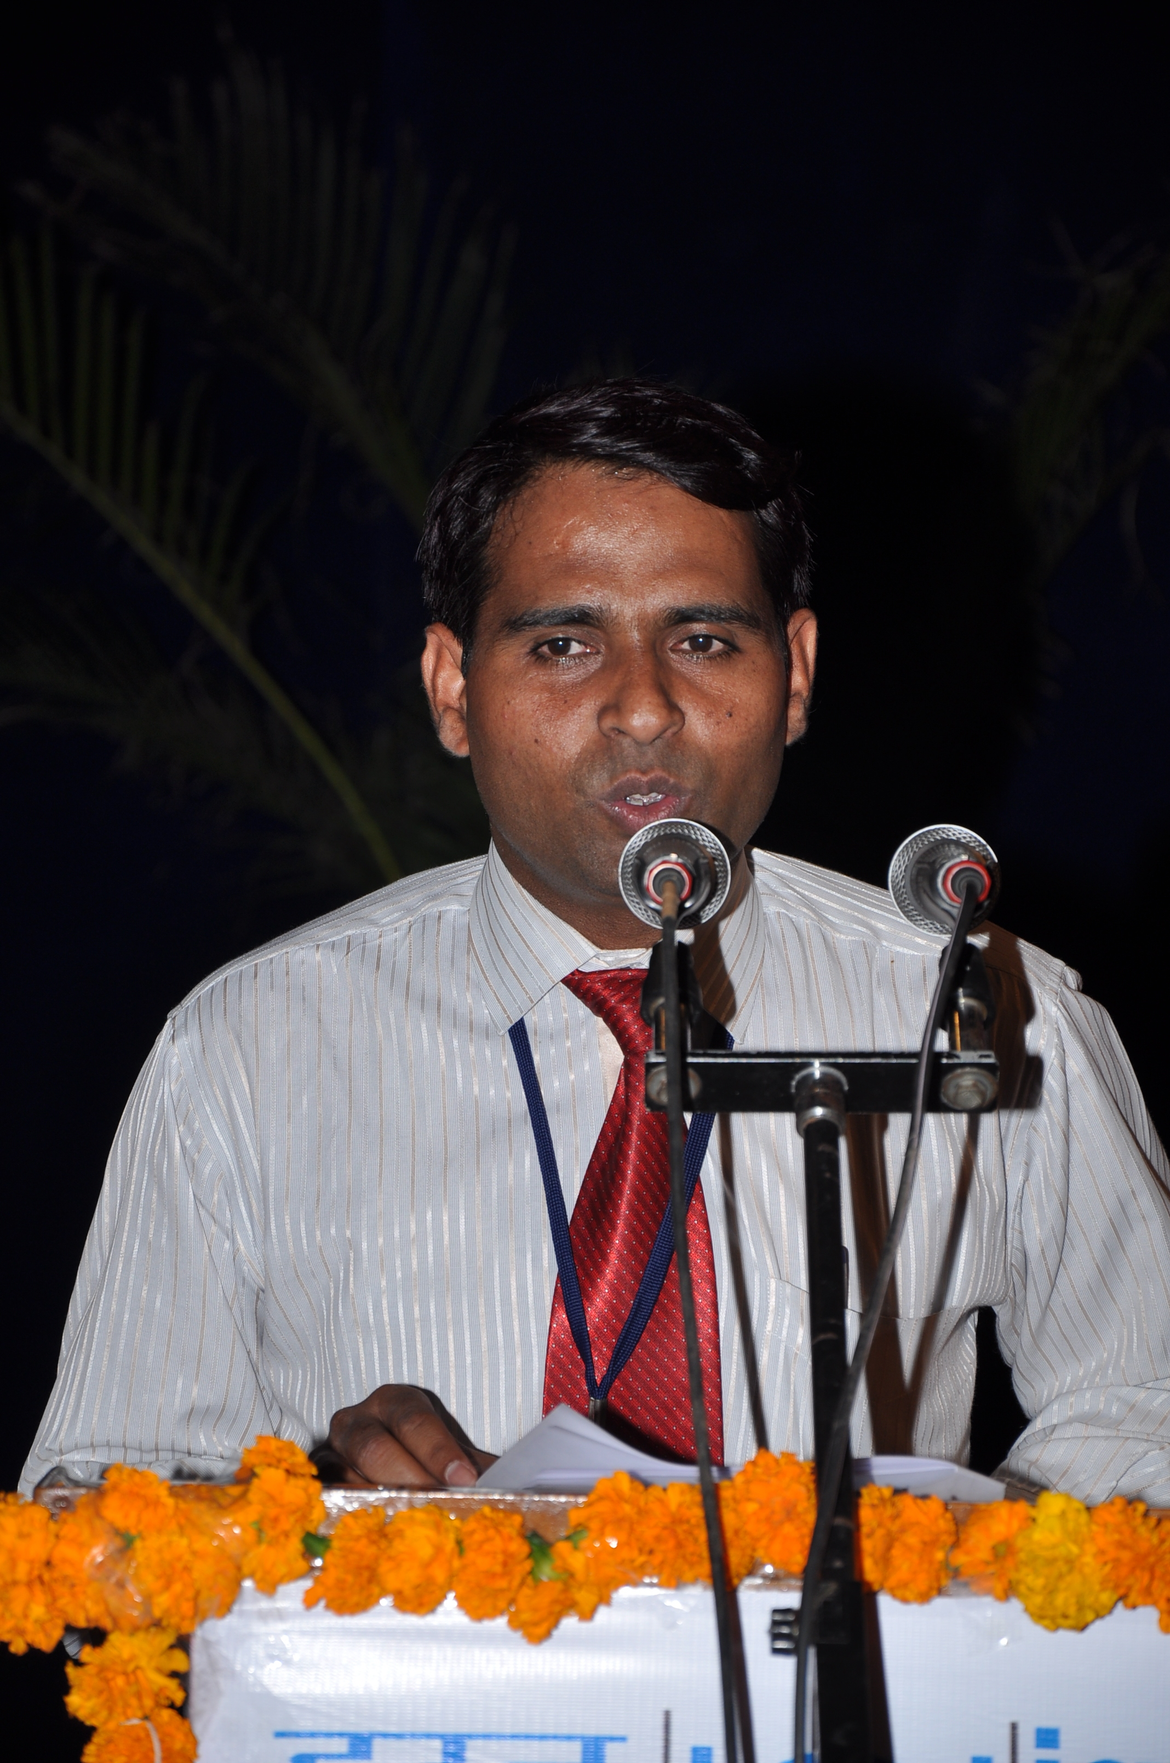
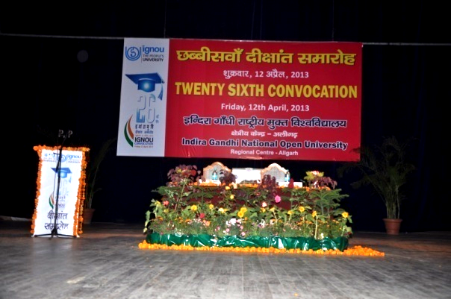
26th Convocation, Guest of Honour and Regional Director Sitting on the Stage.
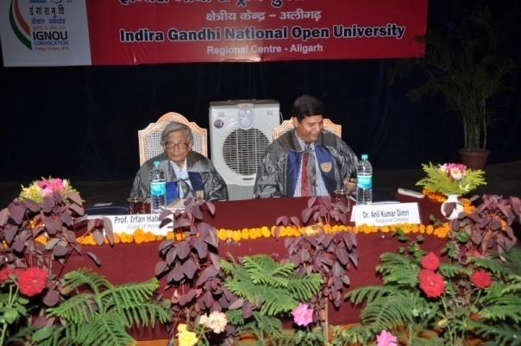
26th Convocation, Guest of Honour and Regional Director Sitting on the Stage.
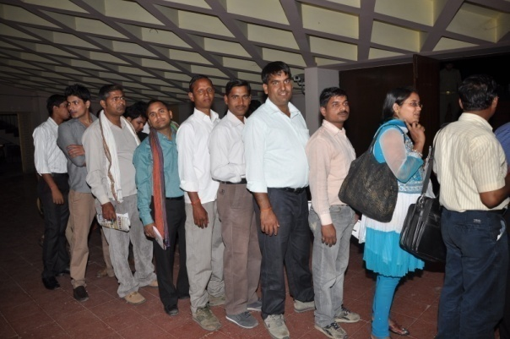
Students in queue at Registration Counter waiting for their tern
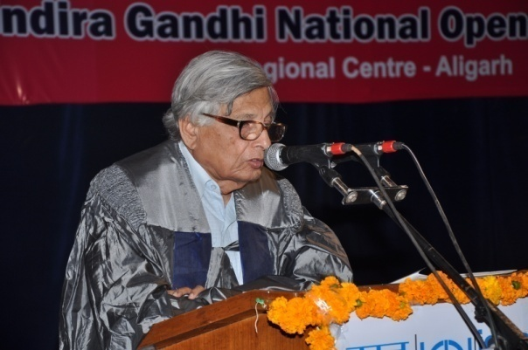
Addressed by Guest of Honour
“Prof. Irfan Habib”
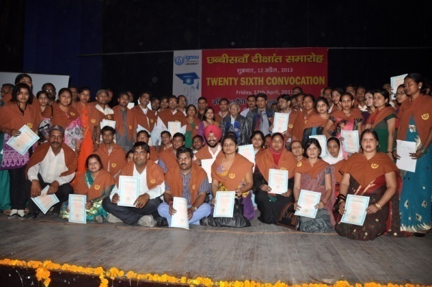
Awardees with Guest of Honour & Regional Director

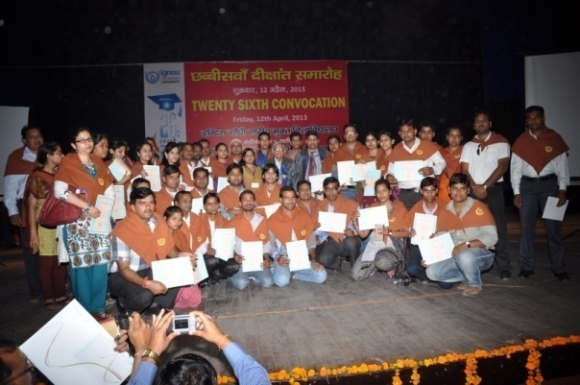
Awardees with Guest of Honour & Regional Director
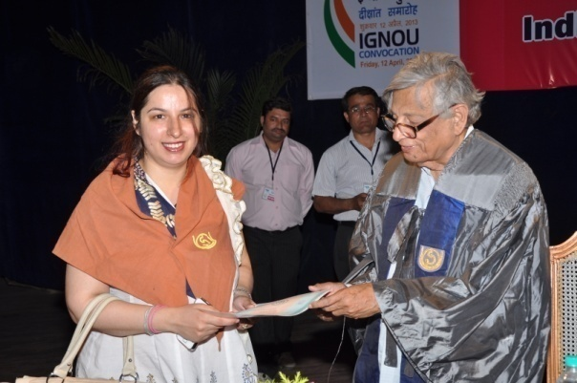
Student receiving Degree from
“Guest of Honour”
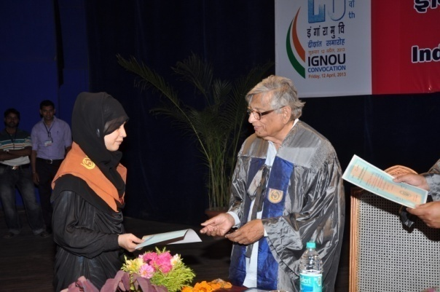
Student receiving Degree from
“Guest of Honour”
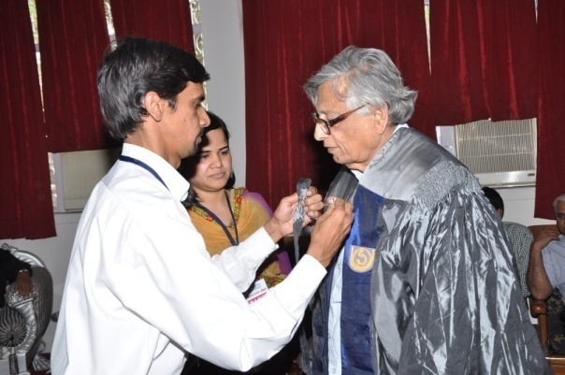
Dr. Ataur Rahman & Dr. K. Nilofer at Robing Ceremony
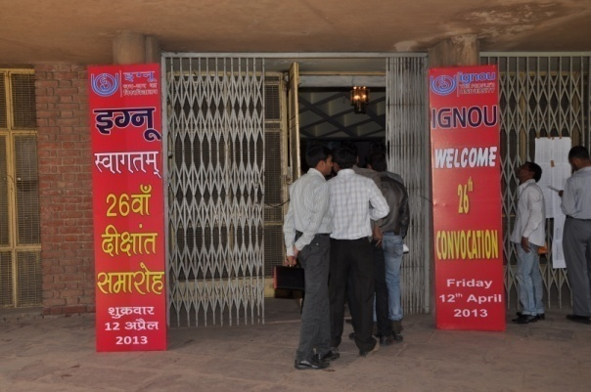
Entrance of Convocation Venue : Kannedy Hall, AMU, Aligarh
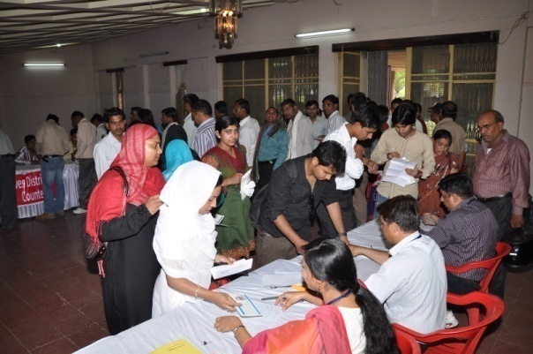
Students at Registration Counter
Students in queue at Registration Counter
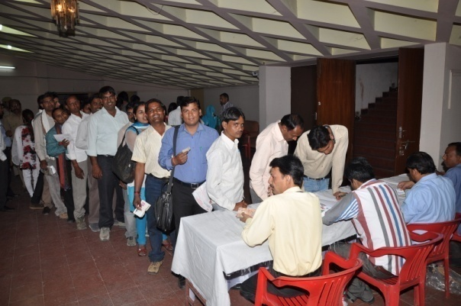
Students at Registration Counter
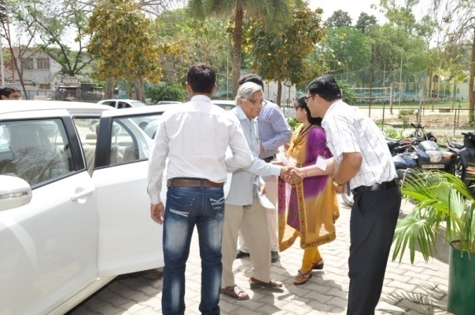
Guest of Honour being received at Convocation Venue
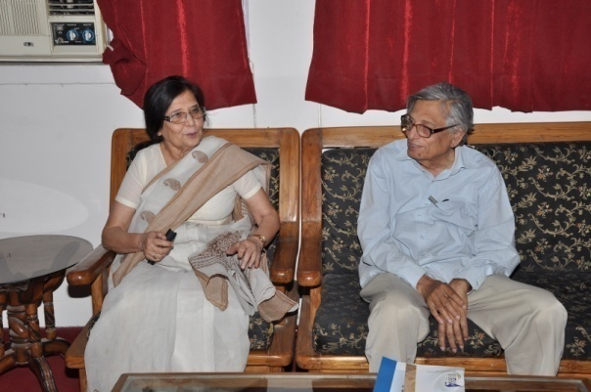
Prof. Irfan Habib, Guest of Honour with Prof. Shireen Moosvi invited Dignitary at Convocation Venue

